Use Loop , Tags, Skip Tags in yaml files and test it using ansible

yaml file with loops and tags
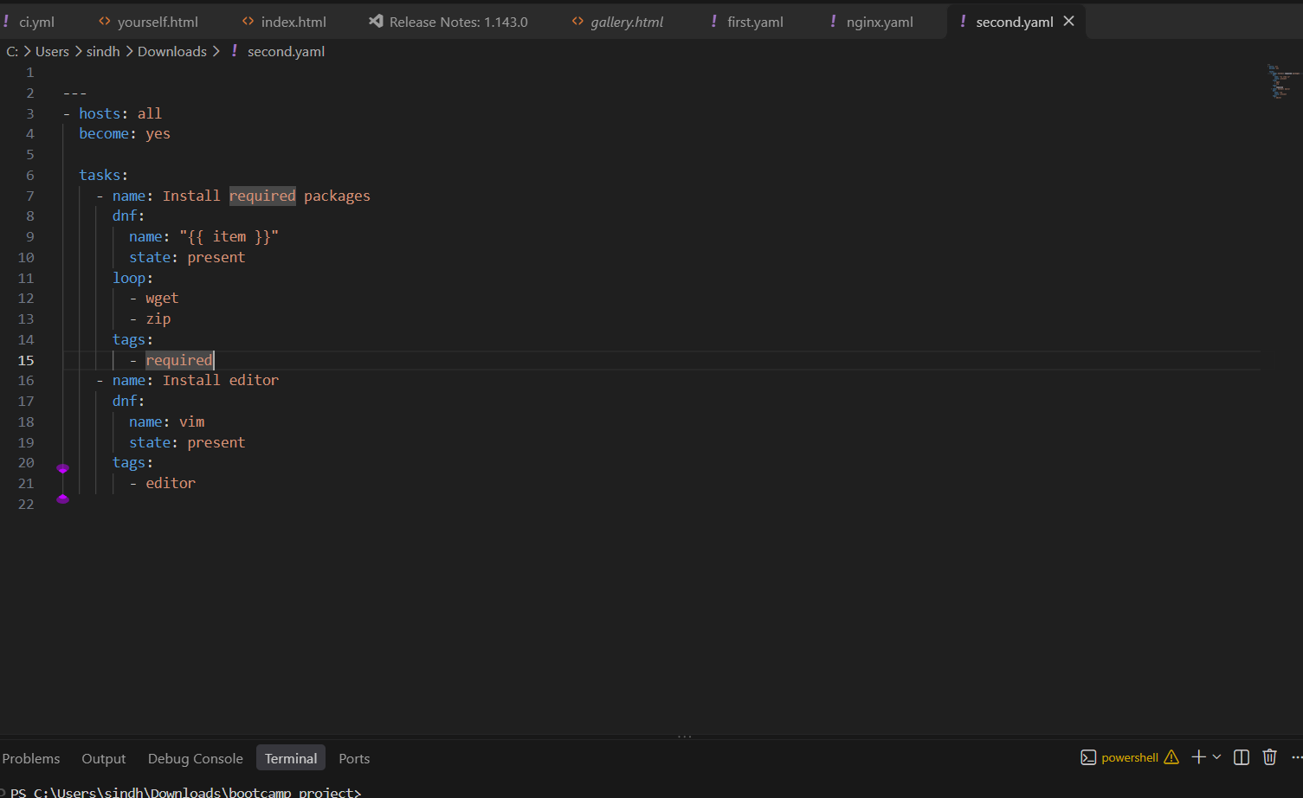
Installing only the packages with tag “required” and it loops and installs all
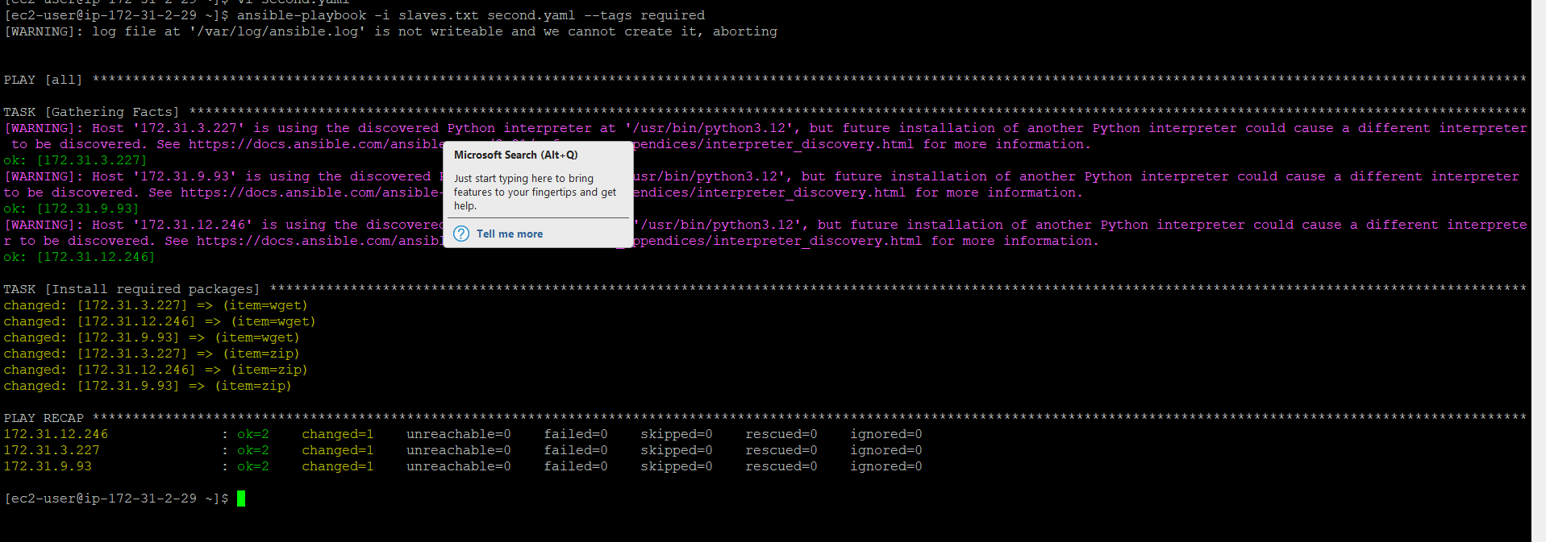
Skip tags is used for required and now the other tag editor is installed
